Elements Of a Trade Setup

2 primary concerns

A. Context or framework surrounding the idea

1. Expansion
2. Retracement

# Reversal

4. Consolidation

B. Reference points in institutional order flow

1. Order blocks
2. FVG and liquidity voids
3. Liquidity pool and stop runs
4. Equilibrium

|  |  |  |  |
| --- | --- | --- | --- |
| Expansion | Orderblock | Elements To A Trade Setup  What is Expansion?  Expansion is when Price moves quickly from a level of Equilibrium,  What is the importance?  When Price leaves a level quickly this indicates a willingness on the pan of the Market Makers to reveal their intended repricing model.  What do we look for in Price? The Orderblock the Market Makers leave at ar near the Equilibrium. |  |

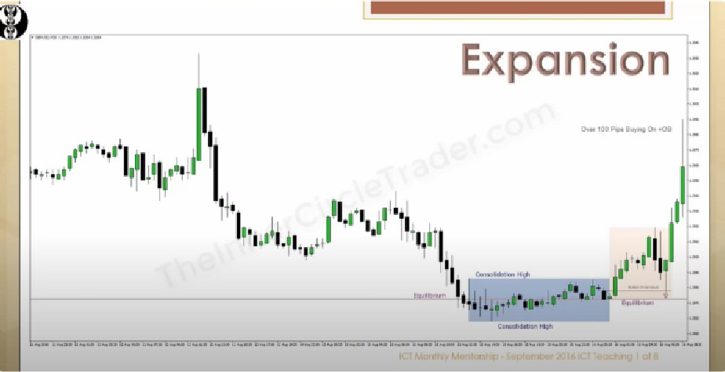Ask yourself, what characteristic are we trading in, then you can build a framework. In consolidation you can say I will not do anything and ill be waiting

Holding pattern: consolidation

Consolidation

Expansion

Retracement

# Reversal

All the moves start from consolidation, that’s where they build orders

Consolidation expansion/impulse swing either back to consolidation or retracement, when retracement happens —+ another level of expansion or after the expansion it can go to a reversal pattern, after reversal pattern —+ retracement consolidation

These 4 conditions interchange trough out

You’re only going to get 1 of these conditions

You need to know where price is at, where is it likely to go, and where it came from

We always wait for the first expansion

|  |  |  |  |
| --- | --- | --- | --- |
|  | Liquidity pools | Elements To A Trade Setup  What is Reversal?  Reversal is when Price moves the opposite direction that current direction has taken it.  What is the importance?  When Price reverses direction it indicates the Market Makers have ran a level of Stops and a significant move should unfold in the new direction.  What do we look for in Price?  The Liquidity Pools just above an old  Price High and just below an old Price |  |

